**How to use the application:**

* After downloading the project go to “Fractional_Knapsack_Along_With_Sorting_Animation.html”
* A page opens in your web browser as shown below
* You have 2 fields

i)Capacity of the bag

ii)How many elements you want to add

* After entering the details, click on “Add” button.
* 4 elements will be created dynamically with the two entry fields for weight and value of each element.
* After entering the weights & values , select the animation speed and type of sorting algo based on which you want to sort the elements.
* Once the elements are sorted according to the weight/value ratio ,elements are copied into another list.
* Now we check if each element can fit into the bucket.If yes,we push the element into bucket.
* If the remaining capacity of the bucket is less than the element’s weight, we break the element and fit into the bucket.This element is marked in red.
* We can see the values of current value and remaining capacity of the bucket for every step.

Screenshots:

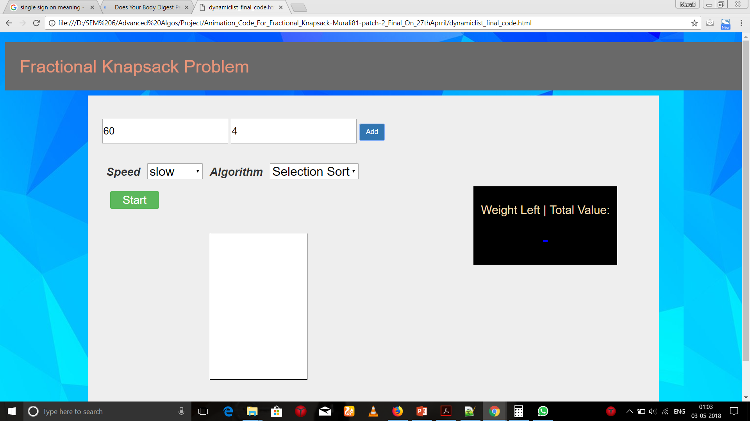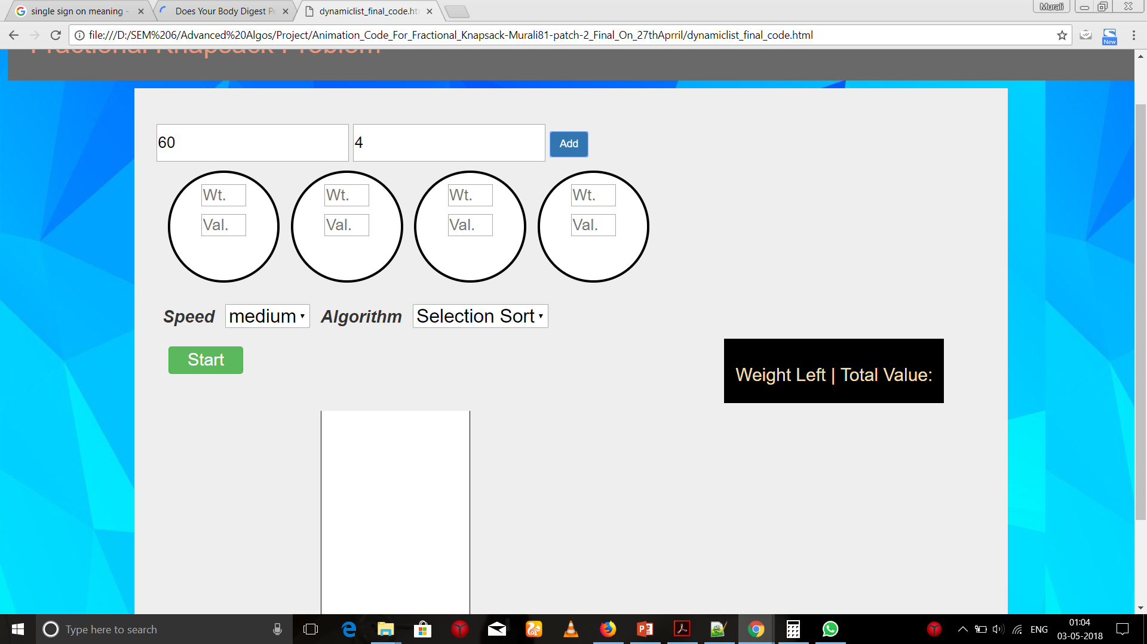

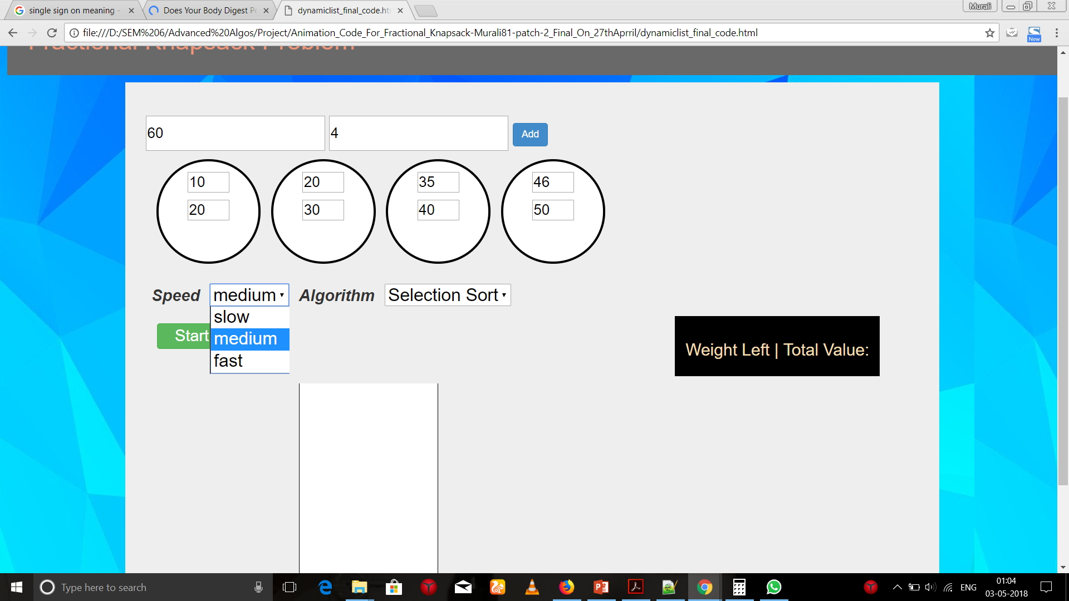

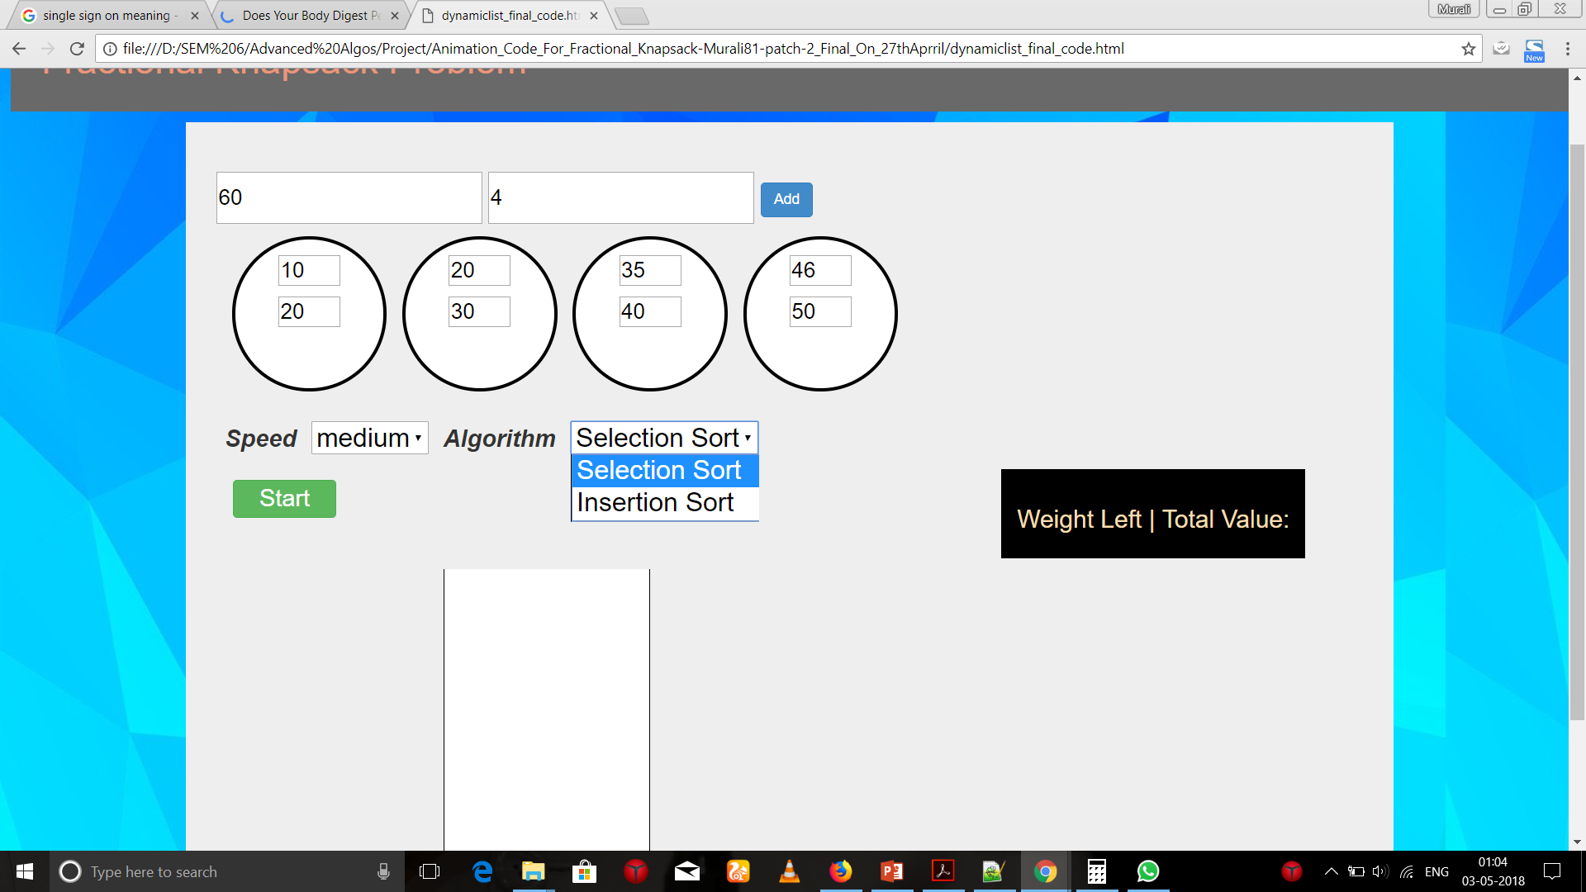

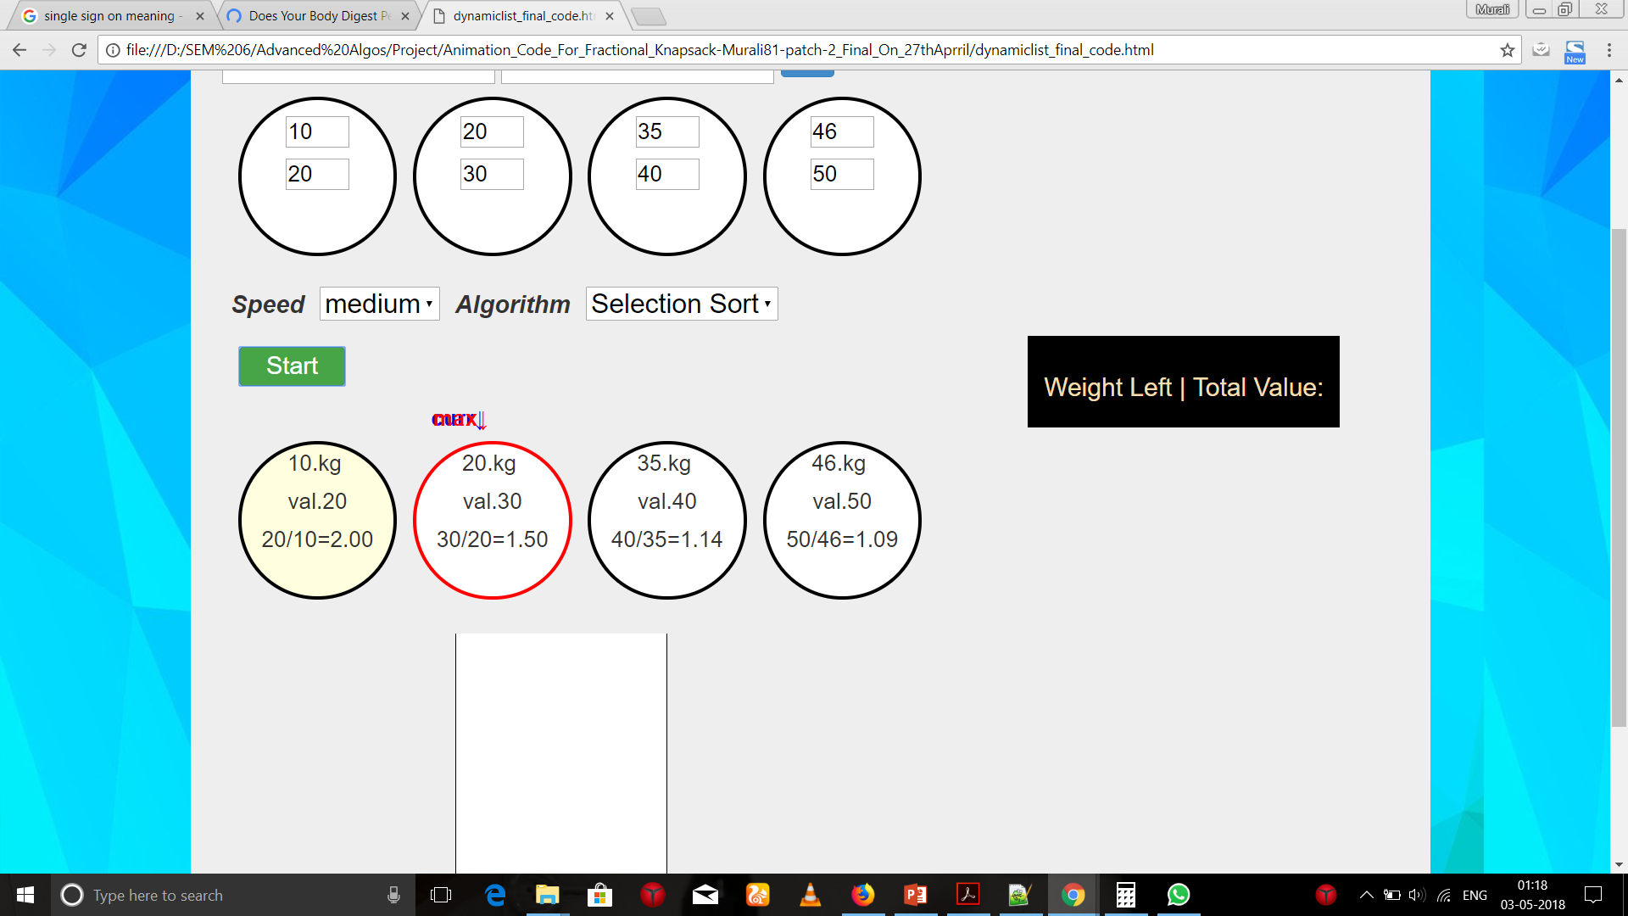

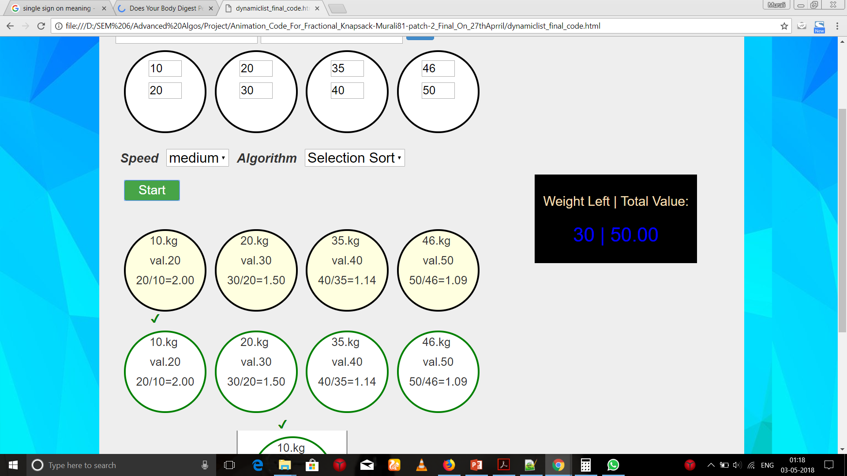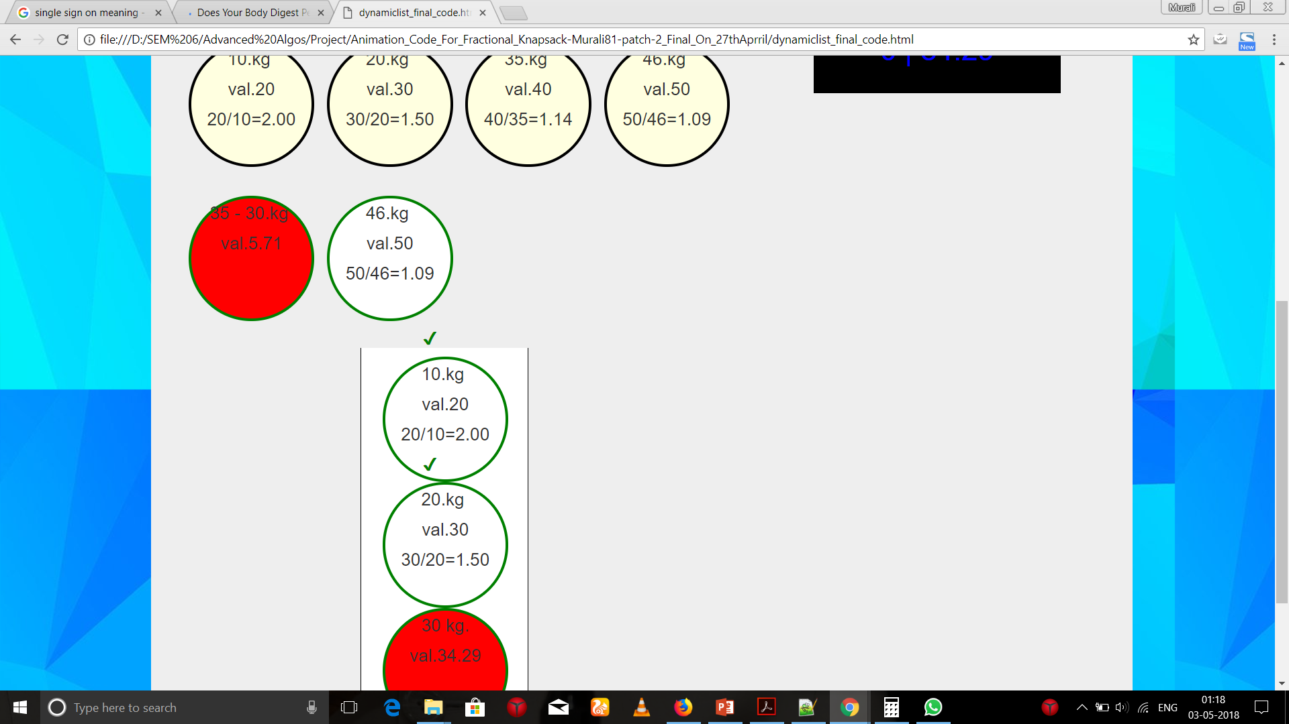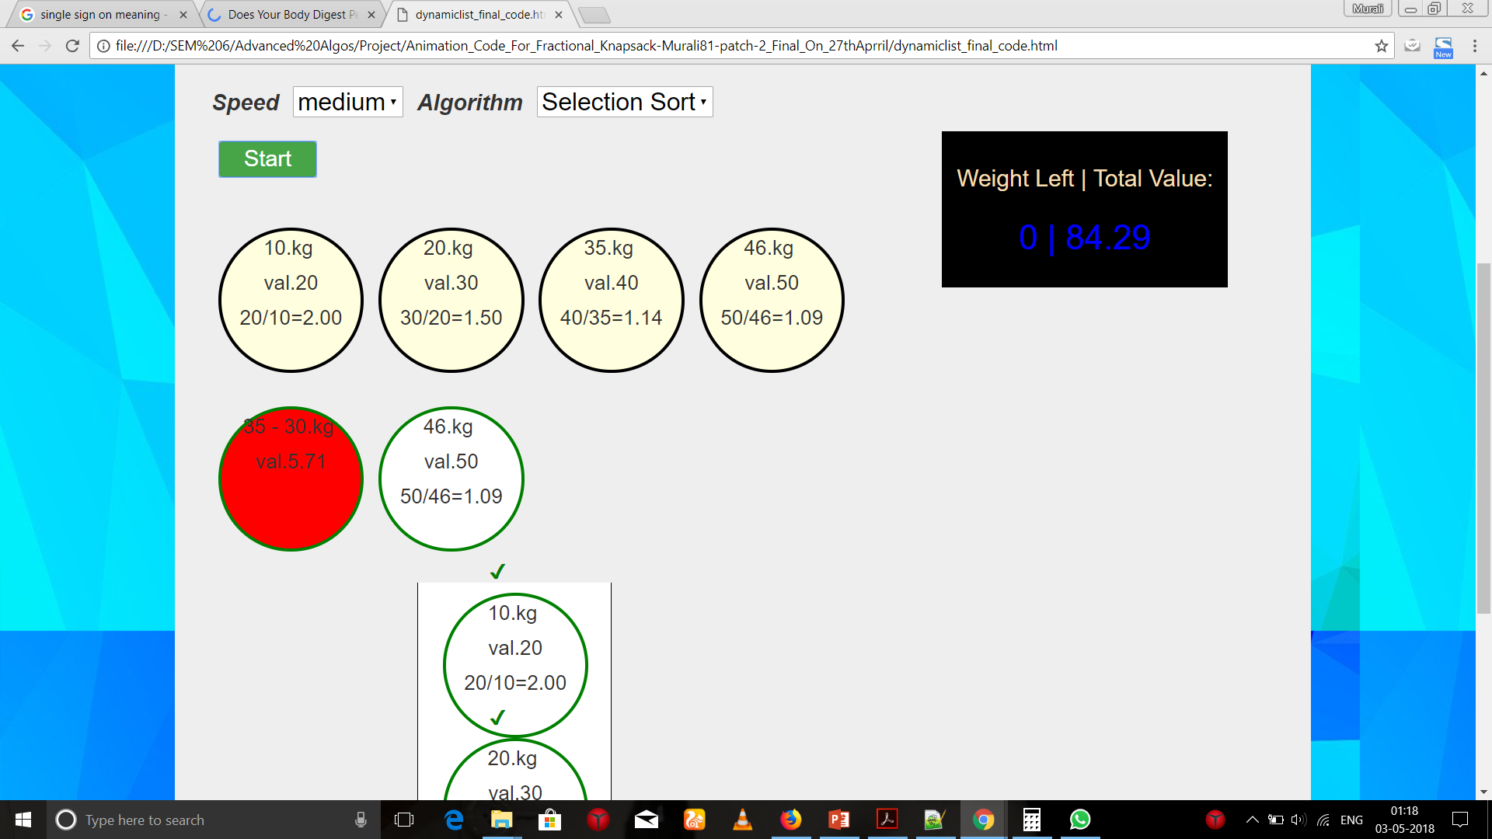

Made by,

Murali Manohar,CSE-2

Nandit Mehra,CSC

2015-2019 batch.